

# THE WORSHIPFUL COMPANY OF FARRIERS

# Candidate’s guide to the Fellowship Communication Skills part:

At the heart of being a Fellow is the ability to teach by communication and to represent our craft. The candidate’s ability to communicate by written and oral presentation is tested in this part of the examination. A candidate is expected to show the same attention to detail and precision that is expected of them in the practical part of the examination. Candidates are required to pass this part, along with the practical part in order to be a Fellow of the Worshipful Company of Farriers. The three sections of the Communication Skills part are show below with the distribution of marks.

*Dissertation*: A candidate has chosen their subject for the dissertation and taken their own time to study and write it and therefore it should be of a high and publishable standard. The Worshipful Company of Farriers (WCF), as copyright holder, will allow public scrutiny online of successful dissertations. The examiners may wish to clarify points from the dissertation and confirm that the candidate has a deep knowledge of their chosen subject. Further guidance for the dissertation is given below. Being invited to Stage Two of the examination does not mean that their Dissertation has ‘passed’. Candidates are being invited to defend their dissertation at stage two, both in their dissertation lecture and the subsequent question session.

*Dissertation lecture*: Candidates are marked on their ability to represent their dissertation orally. They are required to give a 20 minute lecture on the subject of their dissertation and a high standard is expected. Marks are awarded for content, delivery, and timing. They may be asked questions at the end of the lecture.

*Examiners’ chosen lecture*: In the examiners' chosen lecture candidates have only one hour to prepare a lecture on any farriery subject. This section tests a candidates overall knowledge of farriery and their ability to structure a lecture at short notice. Candidates are marked on their content, delivery, and timing. They are expected to satisfy the title set and may be asked questions at the end of the lecture.

*Oral:* At the end of the examiners chosen lecture the candidate will answer questions on that lecture and then the candidate will be subjected to an oral examination which may cover any aspects of farriery.

*Copyright and Plagiarism:*Copyright and plagiarism is taken seriously by the WCF. Examiners will not pass a person who does not adhere to the expected standards of being a Fellow. If a candidate has plagiarised work they will be failed. If at a later date it is found that a successful candidate has stolen another’s work, their FWCF pass will be withdrawn. All illustrations must be the candidates own or by permission of the copyright owner. If permission to use an illustration is given; “By kind permission of.....” must be inserted into the figure legend and written permission shown as an appendix. Any candidate not following this rule will be failed. If in doubt, a candidate must omit material by others.

**Dissertation format**: Although dissertations vary, the basic format should be:

Title page, Acknowledgements, Abstract, Declaration, Contents, Introduction, Methods, Results, Discussion, Conclusion/s, Manufacturers addresses, References, Appendices.

1. The Title page (its own page). See the example below.
2. The Acknowledgements (its own page) should include only those with substantial involvement in the dissertation.
3. The Abstract (its own page) should be no more than 300 words and not contain any references.
4. The Declaration (its own page) should state: *I hereby declare that the work within this Fellowship dissertation is my own. Any sources have been duly referenced and any illustrations or diagrams that are not mine are used with permission of the owner.*
5. Contents (begin new page): should list all contents, from preliminaries to Appendices. At the end of Contents should be a word count which includes the main body of text without the Abstract, figures, tables, Contents, References, Manufacturers and Appendices. Candidates will lose marks for being outside the 3000 to 5000 word range.
6. Introduction: sets out the reason for the study, type of study, literature search, aims and objectives, and where needed, a hypodissertation.
7. Methods (and materials): describes the way in which the study was carried out and where needed, any statistical tests.
8. Results: describe what was found in the study, whether descriptive or statistical.
9. Discussion: is a discussion of the results, to make sense of what the study found. The limitations of the study should be stated here.
10. Conclusions: are drawn from the results and the discussion.
11. Manufacturers’ addresses: must enable the reader to acquire any equipment or materials used in the study.
12. References: should be cited in the appropriate position in the text. The Harvard referencing format should be used.
13. Appendices (begin new page): contains supplementary material to the dissertation such as; interview questions, participant letters / forms, surveys / questionnaires supplemental tables / figures / graphs / images.

**The Fellowship dissertation should be laid as follows:**

**Font size**: 12 **Font type**: Arial or Calabri.

**Page numbering and margins**: Pages should be numbered; bottom centre but the title page not numbered; the Contents should number; Acknowledgements, Abstract, Declaration in lower case Latin numerals, e.g., i, ii, iii. Appendices should be numbered in upper case Latin numerals, e.g., IV, V, VI. The margins should be the default normal for Word, i.e., all 2.54cm.

# Headings:

# First level heading, bold font size 14;

# second level heading, font size 14;

# third level heading, font size 12 bold;

# *fourth level heading, font size 12 italic*.

Line spacing: 1½, with a line gap between paragraphs.

**Illustrations**: diagrams, photographs and graphs should be cited in the text in order (Figure 1, 2, etc). Illustrations should be located in the body of the text as close to but after their first mention. They should be an appropriate size and resolution (300dpi). The legend (description) should be immediately underneath, beginning with the figure number, and the legend in italics; an example is shown below (Figure 1).

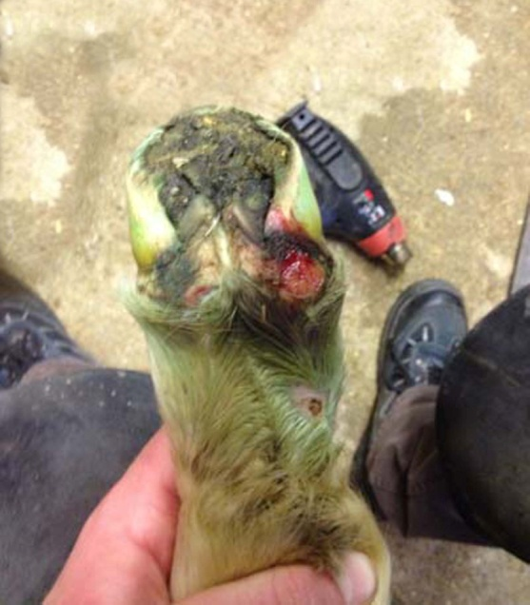

Figure 1: *Flaccid tendon frequently causes lesions to the heel bulbs.*

**Tables**: Tables are cited in the text as (Table 1, 2, etc). They should be located in the body of the text as close to but after their first mention. The title, beginning with Table 1, etc, and description should be above the table and if a legend is required, then this should be below the table; an example is shown below (Table 1).

Table 1: Summary of combined left and right means comparing June to November.

|  |  |  |  |  |  |  |
| --- | --- | --- | --- | --- | --- | --- |
|  | June Mean | | June SE | Nov. Mean | Nov. SE | Difference |
| **Mean age in days:** | 94 |  | | 242 |  | 148 |
| **Metrics in millimetres (mm):** |  |  | |  |  |  |
| Hoof Width | 77.5 | 0.9 | | 100.6 | 1.0 | 23.0 |
| Hoof Length | 77.0 | 0.9 | | 95.3 | 1.3 | 18.3 |
| Heel Width | 50.0 | 0.9 | | 59.4 | 0.9 | 9.4 |
| Hoof Width x-ray | 40.8 | 5.1 | | 92.7 | 0.7 | 51.9 |
| PIII Width | 31.2 | 3.9 | | 65.9 | 0.4 | 34.6 |
| PID | 11.5 | 0.2 | | 13.4 | 0.2 | 1.9 |
| DID | 8.2 | 0.1 | | 11.9 | 0.2 | 3.7 |
|  |  |  | |  |  |  |

*SE, standard error; PID, proximal integument depth; DID, distal integument depth; Hoof Width x-ray, radiographic distal hoof capsule width; PIII Width, radiographic distal phalanx width.*

**Systems of measurement:** Must be in metrics.

**References:** Should be sited at the end of the sentence or paragraph where appropriate. References should be cited in a uniform manner and be listed at the end of the dissertation using the Harvard format, e.g., (Curtis S J, 2014). In the reference list it will appear in alphabetical order as:

Curtis S J, Martin. J. Hobbs S. J., 2014. Hoof renewal time from birth of Thoroughbred foals. *The Veterinary Journal,* pp. 116-117.

# This is the Title of My Fellowship Dissertation

# A N Other

Submitted in partial fulfilment of the requirements for the award of Fellowship of the Worshipful Company of Farriers